Regulatory Committee
Meeting to be held on 13 January 2016

Electoral Division affected:
Skelmersdale Central

Wildlife and Countryside Act 1981
Definitive Map Modification Order Investigation
Addition of a public footpath from Elmers Green to Footway F2696, Skelmersdale, West Lancashire
File No. 804-564
(Annex ‘A’ refers)

Contact for further information:
Megan Brindle, 01772 535604, Paralegal Officer, Legal and Democratic Services,
Megan.brindle@lancashire.gov.uk
Jayne Elliott, 07917 836626, Planning & Environment Group, Public Rights of Way,
Jayne.elliott@lancashire.gov.uk

Executive Summary

Application for the addition of a public footpath to be recorded on the Definitive Map and Statement from Elmers Green to Footway F2696, in accordance with file no. 804-564.

Recommendation

1. That the application for a public footpath from Elmers Green to Footway F2696, Skelmersdale, West Lancashire, in accordance with file no. 804-564, be accepted.

2. That an Order(s) be made pursuant to Section 53 (2)(b) and Section 53 (3)(b) and Section 53 (3) (c)(i) of the Wildlife and Countryside Act 1981 to add a public footpath on the Definitive Map and Statement of Public Rights of Way as shown on the Committee Plan between points A-B-C.

3. That being satisfied that the higher test for confirmation can be met the Order be promoted to confirmation.

Background

An application under Schedule 14 of the Wildlife and Countryside Act 1981 has been received for the addition of a public footpath from a point on Elmers Green, Skelmersdale for a distance of approximately 25 metres to a point on Footway F2696 and shown between points A-B-C on the Committee plan on the Definitive Map and Statement of Public Rights of Way.

The County Council is required by law to investigate the evidence and make a decision based on that evidence as to whether a public right of way exists, and if so its status. Section 53(3)(b) and (c) of the Wildlife and Countryside Act 1981 set out the tests that need to be met when reaching a decision; also current Case Law needs to be applied.

An order will only be made to add a public right of way to the Definitive Map and Statement if the evidence shows that:
- A right of way “subsists” or is “reasonably alleged to subsist”

An order for adding a way on the Definitive Map and Statement will be made if the evidence shows that:
- “the expiration… of any period such that the enjoyment by the public…raises a presumption that the way has been dedicated as a public path or restricted byway”

When considering evidence, if it is shown that a highway existed then highway rights continue to exist (“once a highway, always a highway”) even if a route has since become disused or obstructed unless a legal order stopping up or diverting the rights has been made. Section 53 of the Wildlife and Countryside Act 1981 (as explained in Planning Inspectorate’s Advice Note No. 7) makes it clear that considerations such as suitability, the security of properties and the wishes of adjacent landowners cannot be considered. The Planning Inspectorate’s website also gives guidance about the interpretation of evidence.

The County Council’s decision will be based on the interpretation of the evidence discovered by officers and documents and other evidence supplied by the applicant, landowners, consultees and other interested parties produced to the County Council before the date of the decision. Each piece of evidence will be tested and the evidence overall weighed on the balance of probabilities. It is possible that the Council’s decision may be different from the status given in any original application. The decision may be that the routes have public rights as a footpath, bridleway, restricted byway or byway open to all traffic, or that no such right of way exists. The decision may also be that the routes to be added or deleted vary in length or location from those that were originally considered.

Consultations

West Lancashire Borough Council have been consulted and no response has been received, it is assumed they have no comments to make.

There is no Parish Council for the area.

Applicant/Landowners/Supporters/Objectors

The evidence submitted by the applicant/landowners/supporters/objectors and observations on those comments are included in Advice –Head of Service- Legal and Democratic Services' Observations.

Advice

Head of Service - Planning and Environment

Points annotated on the attached Committee plan.

Point | Grid Reference (SD) | Description
A | 4991 0651 | Open junction with Elmers Green
B | 4993 0653 | Fence across route
C | 4993 0653 | Open junction with Footway F2696

Description of Route

A site inspection was carried out on 15 October 2015.

The route under investigation starts at a point on the footway on Elmers Green (point A on the Committee plan). Elmers Green is a quiet cul de sac consisting of 11 residential properties.

From point A the route passes in an east north easterly direction along what appears to be the garden of 14 Elmers Green. It follows the line of the garden fence which separates 14 and 16 Elmers Green along a strip of lawn between the house and garage consisting of 14 Elmers Green and the wooden fence separating the two properties. The grass is mown and well maintained but it can be seen that the grass along the width of the route under investigation (a strip varying in width from approximately 1.5 to 2 metres) is at a slightly different level and appears to be less established than the grass immediately north of the route. This is consistent with photographs submitted of the route showing that the route had previously had a tarmac surface which appears to have been removed or covered with lawn. No evidence of the tarmac surface remains.

At the rear of the property – at point B - the route under investigation is crossed by a wooden fence which appears to be quite new. It prevents access along the route.

Beyond point B the route under investigation exits the garden directly onto a concrete flagged path which then continues in a generally north westerly direction to Elmers Wood Road. Parallel, but not physically separated from the flagged path, is a tarmac track on which point C is located and which is recorded as Footway F2696. This tarmac path also continues, without its flagged companion, in a south south easterly direction from point C.

The total length of the route is approximately 25 metres.

Map and Documentary Evidence

Document Title | Date | Brief Description of Document & Nature of Evidence
Yates’ Map  of Lancashire | 1786 | Small scale commercial map. Such maps were on sale to the public and hence to be of use to their customers the routes shown had to be available for the public to use. However, they were privately produced without a known system of consultation or checking. Limitations of scale also limited the routes that could be shown.
Observations |  | The route under investigation is not shown.
Investigating Officer's Comments |  | The scale of the map means that the application route, if it did exist at that time, is not shown. No inference can be made.
Greenwood’s Map of Lancashire | 1818 | Small scale commercial map.
Observations |  | The route under investigation is not shown.
Investigating Officer's Comments |  | The scale of the map means that the application route, if it did exist at that time, is not shown. No inference can be made.
Hennet's Map of Lancashire | 1830 | Small scale commercial map.
Observations |  | The route under investigation is not shown.
Investigating Officer's Comments |  | The scale of the map means that the application route, if it did exist at that time, is not shown. No inference can be made.
Canal and Railway Acts |  | Canals and railways were the vital infrastructure for a modernising economy and hence, like motorways and high speed rail links today, legislation enabled these to be built by compulsion where agreement couldn't be reached. It was important to get the details right by making provision for any public rights of way to avoid objections but not to provide expensive crossings unless they really were public rights of way. This information is also often available for proposed canals and railways which were never built.
Observations |  | The land crossed by the route under investigation is not affected by any canals or railways and there do not appear to have been any proposals to construct either in the past.
Investigating Officer's Comments |  | No inference can be drawn.
Tithe Map and Tithe Award or Apportionment | 1839 | Maps and other documents were produced under the Tithe Commutation Act of 1836 to record land capable of producing a crop and what each landowner should pay in lieu of tithes to the church. The maps are usually detailed large scale maps of a parish and while they were not produced specifically to show roads or public rights of way, the maps do show roads quite accurately and can provide useful supporting evidence (in conjunction with the written tithe award) and additional information from which the status of ways may be inferred.
Observations |  | The first edition of the Ordnance Survey map (detailed below) shows the area as undeveloped agricultural land so the Tithe Map was not examined in this instance.
Investigating Officer's Comments |  | No inference can be drawn.
Inclosure Act Award and Maps |  | Inclosure Awards are legal documents made under private acts of Parliament or general acts (post 1801) for reforming medieval farming practices, and also enabled new rights of way layouts in a parish to be made. They can provide conclusive evidence of status.
Observations |  | There is no Inclosure Award for the area crossed by the route under investigation.
Investigating Officer's Comments |  | No inference can be drawn.
6 Inch Ordnance Survey (OS) Map | 1849 | The earliest Ordnance Survey 6 inch map for this area surveyed in 1845 and published in 1849.
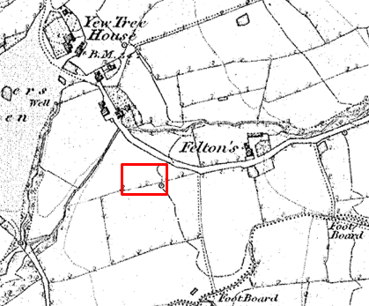
Observations |  | The route under investigation is not shown and the area shown as undeveloped farmland.
Investigating Officer's Comments |  | The route under investigation did not exist in 1845.
25 Inch OS Map | 1893 | The earliest OS map at a scale of 25 inch to the mile. Surveyed in 1892 and published in 1893.
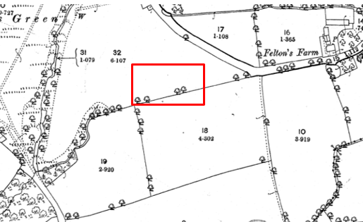
Observations |  | The route under investigation is not shown and the area shown as undeveloped farmland.
Investigating Officer's Comments |  | The route under investigation did not exist in 1892.
25 inch OS Map | 1908 | Further edition of the 25 inch map surveyed in 1892, revised in 1907 and published in 1908.
Observations |  | The route under investigation is not shown and the land is still shown as being agricultural with no changes from the earlier edition of the 25 inch map.
Investigating Officer's Comments |  | The route under investigation did not exist in 1907.
Finance Act 1910 Map | 1910 | The comprehensive survey carried out for the Finance Act 1910, later repealed, was for the purposes of land valuation not recording public rights of way but can often provide very good evidence. Making a false claim for a deduction was an offence although a deduction did not have to be claimed so although there was a financial incentive a public right of way did not have to be admitted.  Maps, valuation books and field books produced under the requirements of the 1910 Finance Act have been examined. The Act required all land in private ownership to be recorded so that it could be valued and the owner taxed on any incremental value if the land was subsequently sold. The maps show land divided into parcels on which tax was levied, and accompanying valuation books provide details of the value of each parcel of land, along with the name of the owner and tenant (where applicable).  An owner of land could claim a reduction in tax if his land was crossed by a public right of way and this can be found in the relevant valuation book. However, the exact route of the right of way was not recorded in the book or on the accompanying map. Where only one path was shown by the Ordnance Survey through the landholding, it is likely that the path shown is the one referred to, but we cannot be certain. In the case where many paths are shown, it is not possible to know which path or paths the valuation book entry refers to. It should also be noted that if no reduction was claimed this does not necessarily mean that no right of way existed.
Observations |  | The Finance Act Records for the land crossed by the route under investigation were not searched as the land was undeveloped agricultural land at that time.
Investigating Officer's Comments |  | No inference can be drawn.
25 Inch OS Map | 1927 | Further edition of 25 inch map (resurveyed 1892, revised in 1926 and published 1927.
Observations |  | The route under investigation is not shown and the land use remains unaltered from earlier editions of the 25 inch mapping.
Investigating Officer's Comments |  | The route under investigation did not exist in 1926.
Authentic Map Directory of South Lancashire by Geographia | Circa 1934 | An independently produced A-Z atlas of Central and South Lancashire published to meet the demand for such a large-scale, detailed street map in the area. The Atlas consisted of a large scale coloured street plan of South Lancashire and included a complete index to streets which includes every 'thoroughfare' named on the map.  The introduction to the atlas states that the publishers gratefully acknowledge the assistance of the various municipal and district surveyors who helped incorporate all new street and trunk roads. The scale selected had enabled them to name 'all but the small, less-important thoroughfares'.
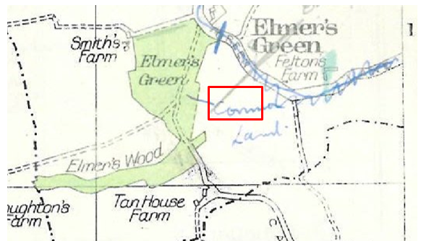
Observations |  | The route under investigation is not shown and the land still appears to be undeveloped agricultural land.
Investigating Officer's Comments |  | The route under investigation did not exist in the 1930s.
Aerial Photograph | 1940s | The earliest set of aerial photographs available was taken just after the Second World War in the 1940s and can be viewed on GIS. The clarity is generally very variable.
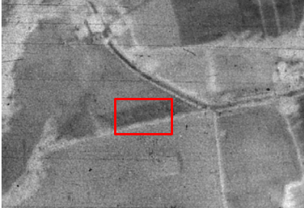
Observations |  | The route under investigation is not shown and the land is agricultural. The field boundaries show up on the photograph and are consistent with the boundaries shown on OS mapping.
Investigating Officer's Comments |  | The route under investigation did not exist in the 1940s.
6 Inch OS Map | 1955 | The OS base map for the Definitive Map, First Review, was published in 1955 at a scale of 6 inches to 1 mile (1:10,560). This map was revised before 1930 and is probably based on the same survey as the 1930s 25-inch map.
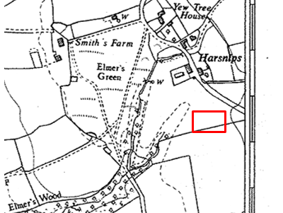
Observations |  | The route under investigation is not shown.
Investigating Officer's Comments |  | The route under investigation did not exist in the 1930s when the map was revised.
1:2500 OS Map | 1960 | Further edition of 25 inch map reconstituted from former county series and revised in 1959 and published in 1960 as national grid series.
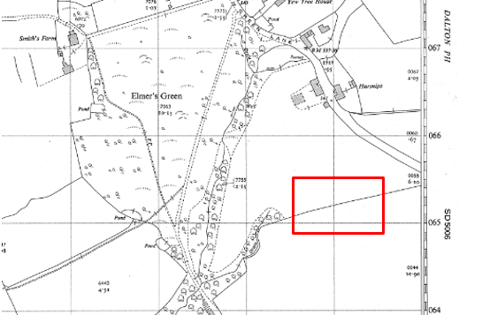
Observations |  | The route under investigation is not shown and the land crossed by it is undeveloped agricultural land.
Investigating Officer's Comments |  | The route under investigation did not exist when the map was revised in 1959.
Aerial photograph | 1960s | The black and white aerial photograph taken in the 1960s and available to view on GIS.
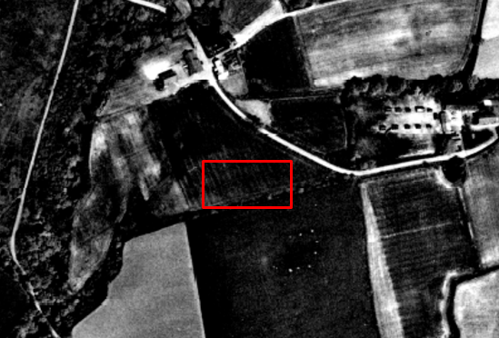
Observations |  | The route under investigation is not shown.
Investigating Officer's Comments |  | The route did not exist in the 1960s.
1:10,000 OS Map | 1972 | OS Map derived from survey carried out in 1959, revised and published 1972.
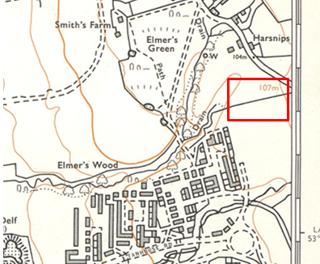
Observations |  | The route under investigation is not shown. The land still appears to be undeveloped agricultural land.
Investigating Officer's Comments |  | The route under investigation did not exist in 1959 and probably did not exist when the map was revised in 1972.
1:2500 OS Map | 1976 | Further edition of 1:2500 scale OS mapping surveyed 1976 and published in 1976.
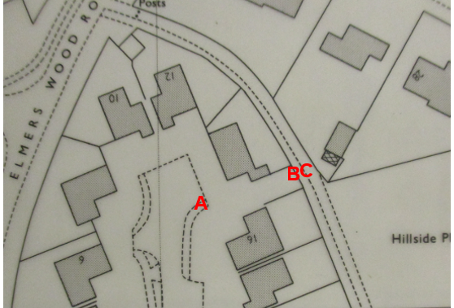
Observations |  | The houses on Elmers Green have been built and a footway is shown to exist providing access to point A. An open area of land exists between property numbers 14 and 16 Elmers Green which does not appear to form part of either property. Access between point A and point B appears to be available but a line is shown across the route at point B indicating that a fence or boundary may have existed across the route. The footway to the rear of Elmers Green and connecting to the route under investigation at point C is shown.
Investigating Officer's Comments |  | The housing development has been built in 1976 providing access to point A and point C. The route under investigation appears to be accessible between point A and point B but it is not possible to know from the map whether access via a gate, stile or gap for example, was available at point B.
Aerial Photograph | 1988 | Aerial photograph available to view at the LCC offices at Cuerden.
Observations |  | Elmers Green is shown and the footway to the rear is visible. A gap can be seen between 14 and 16 Elmers Green but it is not possible to see whether the route under investigation existed or access would have been available.
Investigating Officer's Comments |  | No inference can be drawn.
Print of digital OS image | 2003 | A print of a digital image captured on 1 December 2003 and stated to have been last amended May 2003. Copy available to view at Skelmersdale library.
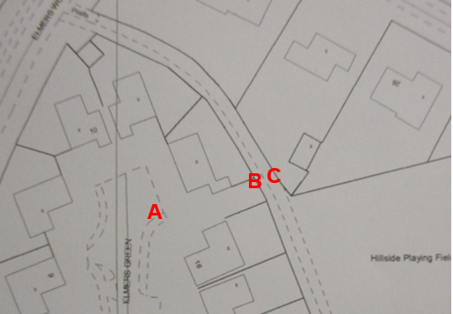
Observations |  | The land crossed by the route under investigation remains unchanged from the 1976 OS mapping detailed above. The route under investigation is not shown
Investigating Officer's Comments |  | The route under investigation appears to be accessible between point A and point B but it is not possible to know from the map whether access was available at point B.
Print of digital OS image | 2006 | A print of a digital image stated to be current to March 2006. Copy available to view at Skelmersdale library.
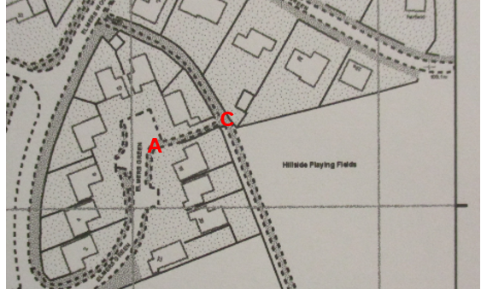
Observations |  | The map shows changes to the boundary fencing between 14 and 16 Elmers Green and shows the route under investigation as a clearly defined route between point A and point C with open access through point B.
Investigating Officer's Comments |  | The route under investigation existed in 2006.
Google Street View | 2009 | Image captured March 2009 and available to view on Google Maps.
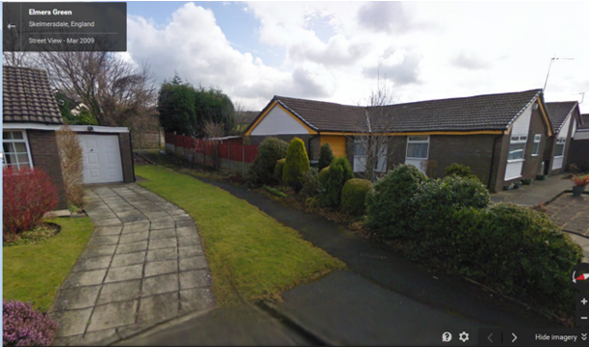
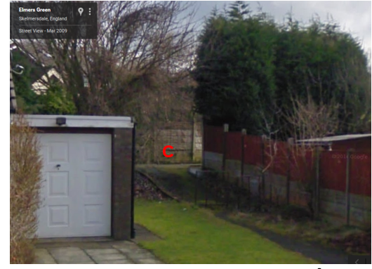
Observations |  | The full length of the route under investigation can be seen as open and available to use. The route has a sealed tarmac surface throughout the full length. Adjacent to the garage of 13 Elmers Green a metal barrier can be seen on the path and vegetation has grown up on part of the surface of the path where use is infrequent due to the need to weave through the barrier.
Investigating Officer's Comments |  | The route under investigation existed in 2009. Metal barriers existed on the route which would not prevent pedestrian use but which may assist to slow down any bicycles using the route and/or prevent vehicular use.
Aerial Photograph | 2010 | Aerial photograph available to view on GIS.
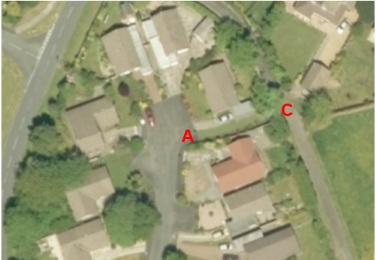
Observations |  | The land crossed by the route under investigation between point A and point C appears to be open and accessible but it is not possible to see whether a surfaced path existed.
Investigating Officer's Comments |  | The route under investigation probably was accessible in 2010.
Definitive Map Records |  | The National Parks and Access to the Countryside Act 1949 required the County Council to prepare a Definitive Map and Statement of Public Rights of Way.  Records were searched in the Lancashire Records Office to find any correspondence concerning the preparation of the Definitive Map in the early 1950s.
Parish Survey Map | 1950-1952 | The initial survey of public rights of way was carried out by the parish council in those areas formerly comprising a rural district council area and by an urban district or municipal borough council in their respective areas. Following completion of the survey the maps and schedules were submitted to the County Council. In the case of municipal boroughs and urban districts the map and schedule produced, was used, without alteration, as the Draft Map and Statement. In the case of parish council survey maps, the information contained therein was reproduced by the County Council on maps covering the whole of a rural district council area. Survey cards, often containing considerable detail exist for most parishes but not for unparished areas.
Observations |  | The route under investigation is in Skelmersdale which is a former Urban District Council. No parish survey map or cards are therefore available.
Draft Map |  | The Draft Maps were given a “relevant date” (1st January 1953) and notice was published that the draft map for Lancashire had been prepared. The draft map was placed on deposit for a minimum period of 4 months on 1st January 1955 for the public, including landowners, to inspect them and report any omissions or other mistakes. Hearings were held into these objections, and recommendations made to accept or reject them on the evidence presented.
Observations |  | The route under investigation was not shown on the Draft Map and no representations were made to the County Council.
Provisional Map |  | Once all representations relating to the publication of the draft map were resolved, the amended Draft Map became the Provisional Map which was published in 1960, and was available for 28 days for inspection. At this stage, only landowners, lessees and tenants could apply for amendments to the map, but the public could not. Objections by this stage had to be made to the Crown Court.
Observations |  | The route under investigation was not shown on the Provisional Map and no representations were made to the County Council.
The First Definitive Map and Statement |  | The Provisional Map, as amended, was published as the Definitive Map in 1962.
Observations |  | The route under investigation was not shown on the First Definitive Map and no representations were made to the County Council.
Revised Definitive Map of Public Rights of Way (First Review) |  | Legislation required that the Definitive Map be reviewed, and legal changes such as diversion orders, extinguishment orders and creation orders be incorporated into a Definitive Map First Review. On 25th April 1975 (except in small areas of the County) the Revised Definitive Map of Public Rights of Way (First Review) was published with a relevant date of 1st September 1966. In a number of Former County Borough areas – including Skelmersdale - the Revised Definitive Map (First Review) was not published until a later date and the map for Skelmersdale was advertised on 6th October 1979. No further reviews of the Definitive Map have been carried out. However, since the coming into operation of the Wildlife and Countryside Act 1981, the Definitive Map has been subject to a continuous review process.
Observations |  | The route under investigation is not shown.
Investigating Officer's Comments |  | From the 1950s through to 1979 there is no indication that the route under investigation was considered to be public right of way by the Surveying Authority. There were no objections or representations made with regards to the fact that the route was not shown on the map when the maps were placed on deposit for inspection at any stage of the preparation of the Definitive Map.
Highway Adoption Records including maps derived from the '1929 Handover Maps' | 1929 to present day | In 1929 the responsibility for district highways passed from district and borough councils to the County Council. For the purposes of the transfer, public highway 'handover' maps were drawn up to identify all of the public highways within the county. These were based on existing Ordnance Survey maps and edited to mark those routes that were public. However, they suffered from several flaws – most particularly, if a right of way was not surfaced it was often not recorded.  A right of way marked on the map is good evidence but many public highways that existed both before and after the handover are not marked. In addition, the handover maps did not have the benefit of any sort of public consultation or scrutiny which may have picked up mistakes or omissions.  The County Council is now required to maintain, under section 31 of the Highways Act 1980, an up to date List of Streets showing which 'streets' are maintained at the public's expense. Whether a road is maintainable at public expense or not does not determine whether it is a highway or not.
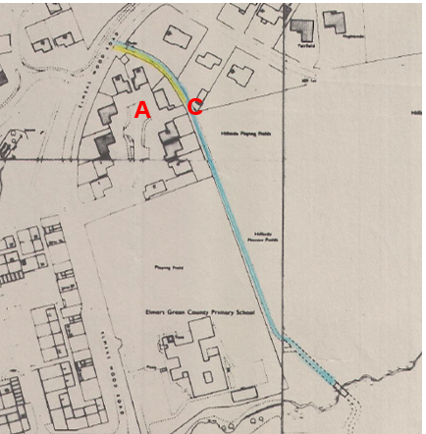
Skelmersdale Corporation Development Plan
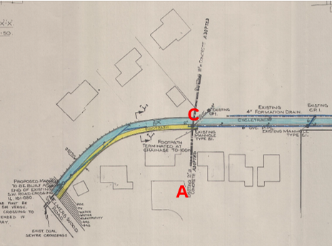
Skelmersdale Corporation Development Plan
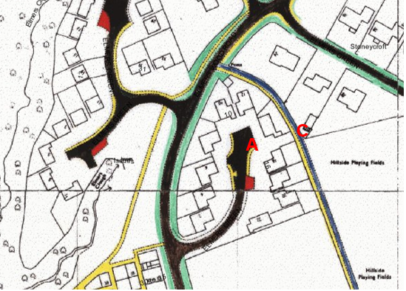
LCC adoption plan available on GIS
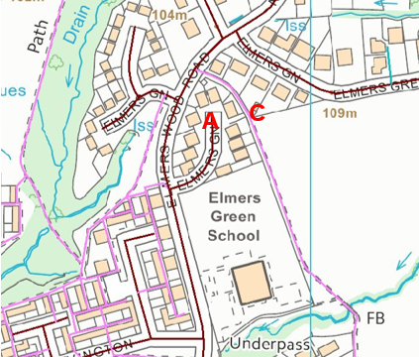
LCC adoption records on GIS
Observations |  | The route under investigation is not recorded as an adopted highway on the List of Streets maintained by the County Council.  Plans deposited with the County Council's Highway team were inspected and a plan entitled Skelmersdale Corporation Development Plan, Tan House/Elmers Green (Minor Works) Adoption of Footpath and Cycle track was found. The plan is dated February 1982 and a handwritten note has been drawn on to it saying 'Submitted for adoption 5.2.82 adopted 24.6.82'.  The key to the plan states that footpaths on the plan are coloured yellow and cycle tracks coloured blue.  The plan shows the full length of a route to be adopted as a cycle track starting on Elmers Wood Road and continuing in a general south easterly direction through point C to a bridge. Parallel to the cycle track a footpath is shown starting on Elmers Wood Road and extending in a general south easterly direction parallel to the cycle track to terminate at point C.  The route under investigation is not shown on the plan as being one of the routes submitted for adoption and the route is not shown to physically exist between properties 14 and 16 Elmers Green. However, the land crossed by the route under investigation does not appear to be shown within the boundaries of either of the two properties.  An insert on the plan shows the routes to be adopted to the rear of Elmers Green in more detail and includes information about physical works to be carried out and services that are present (gas, electric and water). The 'Footpath' to be adopted is shown terminating just south south east of point C on the plan which corresponds with the junction of the route under investigation on the adopted footway. A line is shown along the route under investigation which appears to indicate the existence of an existing water pipe. The note 'Existing 21" ø concrete ADOPTED' is also written adjacent to the pipe between 14 and 16 Elmers Green.  No further plans could be found in the County Council's records referring specifically to the route under investigation.  Further County Council records consist of OS plans that have been annotated to show the routes recorded as publicly maintainable and are referred to internally as the adoption plans. The adoption plan available to view on GIS does not show the route under investigation as an adopted highway. It shows the route to the rear of Elmers Green coloured yellow and blue. Yellow was used to indicate adopted footways and blue is thought to indicate adopted cycle tracks. The footway is shown to extend several hundred metres beyond point C.  The current record of List of Streets has been digitised and is available to view on GIS. It does not show the route under investigation as a publicly maintainable highway and shows the route to the rear of Elmers Green as F2696. It does not record whether there is a separate footpath and cycleway from Elmers Wood Road to 1.5 metres beyond point C.
Investigating Officer's Comments |  | The route under investigation is not recorded as a publicly maintained route on the List of Streets but does not necessarily mean that it isn't one or that it is not a public right of way.  The plans submitted by Skelmersdale Corporation in 1982 are interesting in that they seek to adopt a footway from Elmers Wood Road to point C running parallel to the cycle track and connecting directly to the end of the route under investigation. If pedestrian access along the route under investigation existed (or was proposed to be constructed) this would make sense as a link to the footway and on to Elmerswood Road.
Statutory deposit and declaration made under section 31(6) Highways Act 1980 |  | The owner of land may at any time deposit with the County Council a map and statement indicating what (if any) ways over the land he admits to having been dedicated as highways. A statutory declaration may then be made by that landowner or by his successors in title within ten years from the date of the deposit (or within ten years from the date on which any previous declaration was last lodged) affording protection to a landowner against a claim being made for a public right of way on the basis of future use (always provided that there is no other evidence of an intention to dedicate a public right of way).  Depositing a map, statement and declaration does not take away any rights which have already been established through past use. However, depositing the documents will immediately fix a point at which any unacknowledged rights are brought into question. The onus will then be on anyone claiming that a right of way exists to demonstrate that it has already been established. Under deemed statutory dedication the 20 year period would thus be counted back from the date of the declaration (or from any earlier act that effectively brought the status of the route into question).
Observations |  | No Highways Act Section 31(6) deposits have been lodged with the County Council for the area over which the route under investigation runs.
Investigating Officer's Comments |  | There is no intention by a landowner under this provision of non-intention to dedicate public rights of way over their land.
Land Registry documents |  | Plans and title deeds were obtained from the Land Registry.
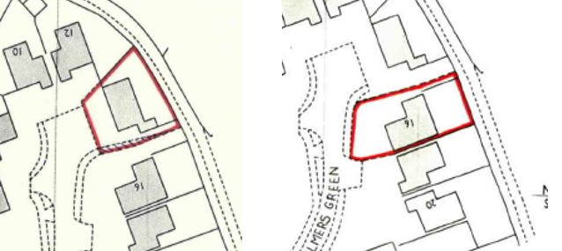
Land Registry Plan LA 546862 Land Registry Plan LA 603895
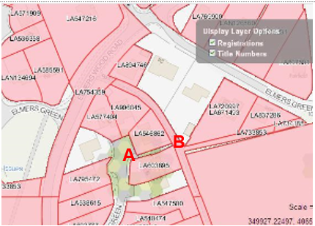
Observations |  | An inspection of the Property Register for 14 Elmers Green provides information regarding the history of the property. It appears that the land was owned by Skelmersdale Corporation and sold to Ashton and McCaul Limited who then sold the leasehold property to Mr and Mrs Rand in 1972. The current owners are listed as purchasing the freehold property in 2005.  16 Elmers Green appears to have originally been sold as a leasehold property to Mr and Mrs Partridge in 1972. The current owners are listed as purchasing the freehold property in 2013.  The current boundaries of the two properties are shown on the title plans and appear to show that a strip of unregistered land exists between the two properties which is consistent with the route under investigation.
Investigating Officer's Comments |  | The two properties appear to have been built in the early 1970s and sold to the original occupiers in 1972.  The information available relates to the current landownership details. For further details of the exact boundaries of the two properties and whether they have altered since the properties were originally constructed it would be necessary to view the deeds to both. These documents have not been made available for inspection.

The affected land is not designated as access land under the Countryside and Rights of Way Act 2000 and is not registered common land.

Landownership

The land crossed by the route under investigation from B-C is owned by West Lancashire Borough Council and the part A-B is unregistered and landownership unknown.

The cul de sac was sold by the Development Corporation to Ashton & McCaul Limited in January 1972 and the sale probably included the land where the claimed route runs. The Limited Company retained ownership and are now dissolved. The land may have passed to the Crown but the owner with the original intention behind constructing the path is now not available.

Summary

There is no map or documentary evidence to suggest that the route under investigation existed before the housing development was built as part of Skelmersdale New Town.

The area concerned appears to have been developed in the early 1970s and access may have been available from 1972 when the houses were built and at least from 1976 (OS 1:2500 map showing a strip of land between the two properties). From 1976 through to the Ordnance Survey map dated 2006 it is not possible to tell from the map evidence whether access was available through the boundary at point B but access does appear to have been available between point A and point B. From 2006 there is clear map and photographic evidence that a clearly defined route existed which passed through the boundary at point B.

There is no record of the route under investigation having been adopted although there is clear evidence (Google Street View) that at some point it was tarmacked and barriers erected to control use by bicycles or motorised vehicles.

The adoption records from Skelmersdale Corporation dated 1982 are interesting in that they relate to the adoption of a footway from Elmers Wood Road to near point C which runs parallel to the cycle track. The site evidence bears out the construction of a flagged 'footway' from Elmers Wood Lane to 1.5m past point C – but not beyond which connected directly to the end of the route under investigation suggesting that pedestrian access along the route under investigation existed (or was proposed to be constructed).

The landownership details available suggest that there is a strip of land between 14 and 16 Elmers Green that was not included as part of either property which would be consistent with the intention to provide a link through from Elmers Green to the adopted footway. Physical changes to the boundary between the two properties have occurred since the properties were originally constructed but the land registry information still appears to show that the strip of land crossed by the route under investigation is not owned by either property.

Head of Service – Legal and Democratic Services Observations

Information from the applicant

The applicant has provided the following information in support of the application.

"Background
Skelmersdale was laid out as a New Town in the early 1960's. Footpaths were part of the design infrastructure feature to separate pedestrians from road traffic, resulting in a network of footpaths linking community assets and communities together.
This part of Tanhouse was developed in the early 1970's by Whelmar Homes as a private housing estate of detached houses and bungalows, making up 5 cul-de sacs comprising homes of similar style.

We are told that the path was maintained by West Lancs District Council until transfer in 1984, however for some unknown reason LCC failed to adopt it as part of the highway. In the early 1990s WLDC put stagger gates on the path to deter motor cyclists who used it to cut through from the Tanhouse estate to Beacon Park. This is the only "cut" from the Whelmar estate to have such gates.

Both properties on each side of the path have been in the same ownership for many years. The lady who owned No16 until 2 years ago, is in the 90s and is in a Care Home. She always understood it to be a right of way. The family of the lady at No14 (now diseased) also believe it to be a right of way, and used it extensively.

Map 1
Shows the location of the footpath site on 1:25000 OS map.
It can be found on Explorer 285, Southport & Chorley, grid ref 499065
Map 2
No plans of the original Whelmar development exist. I have checked with WLBC, hoping they were stored on microfiche, but am told they were sent to Homes and Communities Agency in Warrington. They tell me they were sent to Bedford, but am told that all old plans of Skelmersdale were destroyed in 2005. I have visited, and checked at the Lancashire Records Office, but only small samples of street layouts have been kept as an example of the town's layout. There are no records of this development. Map 2 shows the 1993 map of part of the Whelmar development at Eavesdale, Earlswood, and Eastleigh. The final phase of development, which includes the site of concern is just off the map to the north. The map clearly shows the developer's intention to create footpath links between the cul-de-sacs and the main arterial footpath to, and along Hillside Playing fields. This path was designed as the main north-south arterial link between communities and the former St Richards High School (now redeveloped as Holland Park). Existing footpath links are shown circled from Earlswood and Eastleigh, proving the developer's intention to allow residents access to the path, and the Hillside playing fields.
Map 3
This later map, shows the last developed cul-de-sac. Unfortunately the map shows the space, but no path, and a line where the footpath entry exists. I am unable to find a map of this area from the same date and scale as the previous map at Skelmersdale Library or the Lancashire Record Office. I'm assuming this is a cartographical error that has gone un-noticed or challenged over the years.

Picture 4
This shows 2 images of the footpath link between nos 14-16 Elmers Green in March 2009, taken from Google Street view, proving the existence of the footpath link. The Hillside playing field path can be seen in front of the concrete panel fence. The 2 metal gates that stagger access can just be seen. The width of the tarmac becomes narrow at the 1st gate as pedestrian access is limited. No 16 has a wooden fence while No14 has no boundary treatment.

Map 5
This Mario Map is taken from WLBC website, showing that WLBC recognise the existence of the link through the cul-de-sac. Further scrutiny, shows the footpath linking with another footpath at Evington to the south.
While the Elmers Green cul-de-sac does have some pavements, there are no pavements on Elmers Wood Road, further reinforcing the idea that pedestrians and vehicles were designed to be separate. The map shows that the only safe access to Hillside playing fields from this part of Tanhouse was designed to use this link.

Map 6
Another, more detailed Mario map, this time LCC website, showing the path access as it was designed and is in reality.

Map 7
A current, up to date map is taken from WLBC website, again showing the link footpath and up to date relevant user information.

Maps 8
Here are 2 Land Registry maps for numbers 14 and 16 Elmers Green, showing curtilage details. When held over each other, it is clear to see that neither have ownership of the land in the middle. This space is shown on the previous Mario maps as the footpath link. Since the land is not in resident ownership, it is clear that when the site was laid out, it was the developer's intention that the path be adopted. The photographs for Google Street view support that idea.

Map 9
A map from the mid 1970s published by Skelmersdale development Corporation, for residents use, shows the arterial footpath links in the neighbourhood.

Photographs 10
these images, taken in Autumn 2014 show the link footpath blocked by a 6 foot wooden fence preventing access from the cul-de-sac to the hillside playing field path. These images are taken from the same position as those taken in 2009 by Google street view, thus showing before and after. They show the metal gates which were installed many years ago.
In recent weeks the gates have been removed and turfs of grass have been placed over the tarmac in an attempt to disguise the appearance of the footpath.
Present
My concern is that the access was blocked unexpectedly, with no consultation in the neighbourhood. No 16 was sold in the summer of 2014, having been in the same ownership for many years with no problems regarding the footpath. It is assumed that the new owner has been implicated in blocking the access, but there is no proof of this.
I believe that if someone should want to block off the access, then they should follow set consultation procedure with the wider community. This has not been done. Should this unauthorised blocking of access be accepted in this unauthorised way remain unchallenged, then it sets a principle that anybody can do the same, in a town that was designed with footpaths at the forefront of the planners mind.

I accept that some similar links can be contentious; however in the whole time I have known this cul-de-sac, there have been no concerns raised until recent months when property has changed hands. Records from Rightmove show that this is a very stable community with very little change on property ownership over the years.
I understand that as a result of the Prescription Act 1832, that after 20 years of use a prescriptive right can arise."
In further support of the application the applicant has provided a written statement from Tanhouse Councillor Bob Pendleton, the information is set out below:

"I write this letter simply to say that I have used this path for many years in my capacity as Ward Councillor delivering leaflets, newsletters and canvassing. Also walked my family to Beacon Park in the 1970/80s.
It's important to remember that Skelmersdale was built for pedestrian's to have the ability to walk across the town and never having to cross the main roads, that is why there is public footpaths leading into all housing estates and linking the next estate by foot, the other point I would point out is that there is no pavement's on the side of any Main road and estate roads. Estates being built today footpath links are part of the developments."

In support of the application, the applicant has provided 18 user evidence forms, 2 of these forms are of a different type and some questions were not asked along with the other 16, the evidence from these forms is set out below:

The years in which the users have known the route varies:
1975-2015(1) 1980-2015(1) 1984-2000(1) 1985-2015(1)
1987-2015(1) 1989-2015(3) 2000-2015(3) 2007-2015(1)
2010-2015(2) 2012-2015(1)
2 users were not asked this question and 1 user did not provide a response.

17 users have used the route on foot and 1 user has used it in their wheel chair, the years in which the users have used the route are as follows:
1974-2014(1) 1975-2014(1) 1976-2014(1) 1976-2015(1)
1977-2015(1) 1984-2000(1) 1985-2015(1) 1989-2015(2)
1995-2010(1) 2000-2014(1) 2000-2015(1) 2006-2014(1)
2010-2012(1) 2010-2014(1) 2012-2013(1)
1 user has used the route in 1989 and another user has used the route in 1999.
The main places the users were going to and from include Ashurst, Edenhurst, Birch Green, to School, the Concourse, to the fields, visiting a family home, Felton Farm, the Beacon, the doctors, visit friends in Digmor and for a circular walk. The main purposes for using the route include, exploring the area, used the route as there are no footpaths along the main road, dog walking, visiting friends / family, for pleasure and recreation, and for delivering leaflets as the role of being a war Councillor.

The user of the route per year varies from 2-5, monthly, weekly, 100 times, 350 times, and some users answered with 'many', 'frequently', 'every now and again', 'uncountable times', 'when children were smaller everyday now less frequent'.

1 user states they have used the route on horseback and on a push bike between the years of 1993-2014. 2 other users have also used the route on push bike, 1 of these users didn’t provide any dates and the other user used it between the years of 1994-2014 1-12 times per year.

1 user has seen others using the way on horseback (as well as on foot) between the years of 1989-2014. 11 users have also seen others using the way on foot, the following dates have been provided, 2000-2015, 2010-2014, 1990-2015, 1989-2014, 1985-2014, 1987-2014, 1984-2000. 1 user also saw others using the way on foot and on bicycle between the years of 1984-2014. 2 users stated 'yes' when asked if they have seen others using the way but no further details were provided.

When asked if the route has always run over the same line, all 18 users responded with 'yes'. 10 users mention there are offset barriers along the route and some users state these are to deter motorcycles. 1 user mentions there is a fence along the route but states it did not prevent any access, 1 user responded 'not until now' in response to there being any stiles / gates / fences and stated it has prevented access since 'Christmas 2014'. 6 users state that there are no stiles / gates / fences along the route.

15 users state they have never worked for a landowner over which the route crosses nor have they ever been a tenant, 3 users did not provide a response to this question.
11 users have never been stopped or turned back when using the route, 1 user mentions they have been stopped by 'the fence erected by the new home owner', and states 'not until the fence was put up', and 1 user states 'yes, when the fence was built to block the path'. 1 user responded with 'yes' but provided no further details, and 3 users did not provide a response to this question.

9 users have not heard of anyone else being stopped or having to turn back when using the route. 4 users mention they heard of others being topped once the fence was erected, 1 user states 'a few months ago when the temporary red fence was erected then the new 10 foot wooden fence was put up', and 4 users did not provide a response.

When asked if they were ever told the route they were using was not public or if they had ever seen any signs or notices, the users responded with 'no' or did not provide a response to this question.

None of the users have ever asked permission to use the route and 1 user states 'the path opened when the bungalows were built – over 40 years ago to use the path to school'.

After completing the form users are asked to provide any further information they feel is necessary, these responses are set out below:
- My husband has lived in Skelmersdale for 40+ years and that way has never been blocked off to his knowledge. We used to use the way daily to walk our children to school
- Many people have used the route over the years including dog walkers and children and local residents
- I've used the route regularly and it is inconvenient now that a home owner has erected a fence and blocked the way
- This path has been used by walkers for as long as we have lived here. i think it is wrong when now someone who knew the path was there when they bought the property should be allowed to deny us right of way
- As long as my family has lived in Elmers Green it has always been a footpath
- All the local residents have used the footpath over the years. Many people use the path for dog walking. School children access to the Beacon
- Most local residents have used the path over the years. The previous owner who lived in the property until 2 years ago believes it is to be a public right of way. People in the community have used the path and have tried to use it
- I have used this footpath a number of times and walked and cycled past it over 100's of times from 1987-2014 and there was never an obstruction until the fence was erected in 2014. I presume the path was laid by the developer of numbers 2-22 Elmers green, it has a macadam finish and offset barriers to prevent vehicular traffic and has been maintained by the Local Authority. I knew a previous residents of 14 Elmers Green, between approximately 1987-2005 who was a dog owner who used this path daily.
- My partner and I often use this walk while visiting my partner's father who lived in Eastleigh. We moved away in 2000 so our walks there have ceased on that date
- High wooden fence summer 2014.

Information from others

An objection has been received from Mr A Timson along with comments made on the applicant's user evidence forms, comments on the applicant's maps and photographic evidence and letters of objections from residents of the cul-de-sac, this information is set out below:

Cover letter of objection from Mr and Mrs Timson
The following information is provided in the cover letter from Mr and Mrs Timson:

- there 11 bungalows in the cul-de-sac mainly occupied by residents of 65+ year old and at least 6 of the residents have resided there since the properties were built
- Of the 11 properties since the application was made 2 of the residents have since passed away (no 14 & 18) and the properties are now empty, of the remaining 9 properties, 1 resident due to health and memory problems is not capable of objecting, 1 is the applicant and the other 7 property owners are objecting
- despite the applicant's knocking on every door in Elmers Green (100+ houses) the support for this application is limited and those 11 properties were not asked to support the application and only found out about it once it had been submitted
- the land first started off as a track for the builders to access the rear of the properties with machinery and materials, at the time Hillside footpath was itself no more than a wide rough track its full length
- When the builder finished the development they built a fence to block off the land where it meets Hillside footpath and turfed the area and for many years the area was cut and maintained by the residents of numbers 14 & 16 and over a period of time the fence fell into disrepair
- at some stage the Local Authority at that time (New Town Development Corporation) made Hillside path into a cycle / footpath by laying tarmac and at the same time without any authority from the landowner places some tarmac along the land between 14 & 16 and from the day the tarmac was put down between the two bungalows it has never been maintained or adopted by any residents or local authority
- Elmers Green School burnt down in late 1989 and it was rebuilt and reopened as a special school with children being transported to the school from all over Lancashire, the children and staff arrive at the school by vehicle as there is no pedestrian access to this school and there hasn’t been for at least 20 years
- At no time can anybody remember people using this land to access the school but many children were taken to school from other estates attached to the Hillside footpath by walking along Hillside footpath to the school gate which was approximately half way down Hillside footpath, the gate was closed off when the school was burnt down
- The person who describes taking her children to this school in her evidence is in her seventies and her children will be in their thirties / forties, from her address the route to the school would take them down Hillside footpath and without massive and improbable detours would not involve them coming into the cul de sac
- Mr and Mrs Timson moved into No.16 and state the land had not been maintained for at least 20 years and two thirds of the way up there are offset barriers that were overgrown and blocked making it impossible to walk from the cul-de-sac to the Hillside footpath without walking around the barriers onto the side lawn of number 14
- There were 2 large trees adjacent to No.14's garden which were over grown and hung over the said land making access impossible, the largest of the trees has since been removed
- There has been a lot of youths congregating near the said land and they have been caught on CCTV and reported to the police
- After discussions with the residents they phoned West Lancs Borough Council and asked for the land to be blocked off and they informed them it was not part of the Council's network. They then contacted LCC and was informed by it was not part of their network, it was not a public footpath and was on private land and it could be blocked off, this information was provided by Ros Paulson
- In August 2014 residents attempted to prevent access on the lawn to the side of No.14, but this was always disturbed by youths (as caught on CCTV) and so the residents joined together to pay for the wooden fence at the boundary of the Hillside footpath and state this is in the same position as the fence shown on the early copies of the original land registry deeds
- They are objecting mainly because of crime
- The said land has not been used for people and families to access any amenities, parks, dog walking, shops etc
- After reading the application evidence believe the maps are dodgy and photographs doctored and the applicant and his witnesses are trying to deceive the Council into believing this cul-de-sac is a semi motorway not a cul-de-sac where visitors particularly pedestrians are a rare sight

Comments on user evidence forms

User evidence form A

- This user states the bungalows were built by Whelmar Development when in fact many of the houses on Elmers Green were built by small private developers, in this case it was Ashton & McCaul Ltd as stated on the deeds and as such not all cul de sacs on Elmers Green are connected in the same way to the footpath network
- The user states to 3 other estates, Eastleigh, Earlswood and Eavesdale these are not part of Elmers Green but of Tanhouse area of Skelmersdale, these three estates were developed by Whelmar
- The user used the route for 38 years on a monthly basis but lacks details of why they were using the route, who they were visiting, and where they were going to and from, especially when they have never lived in Skelmersdale why have they used this tiny stretch of land
- The user used the route to visit friends and for dog walking but has lived on a farm since 1987 in the middle of the countryside in Dalton
- Mr and Mrs Timson state the only friend he has visited is Mr Kelsall (applicant) according to their CCTV he has visited 4 times in 2015 by car and has never been seen before by any resident in any year
- The user states using the route until the wooden fence was put up in November 2014, but this is incorrect as prior to the wooden fence plastic barriers were in place from August 2014
- The user lives on a farm in Dalton past numerous country parks and golf courses and brings their dog to a small residential cul-de-sac, does this seem credible

User evidence form B

- Does not provide full details of the route taken from the Ashurst area to Elmers Green
- There is no direct or indirect footpath route from Kestrel Park to Digmoor passing through the cul-de-sac
- Use of 1012 times per year is vague and an indeterminate amount
- User has claimed to sue the route on bicycle but there are offset barriers along the route
- Years of use contradicts through the form from 1995-2014 to 1995-2010
- Doesn’t provide details of the offset barriers or when the wooden fence was erected
- Answers "I have used this footpath a number of times", "and walked and cycled past it over 100's of times" are vague and unspecific
- "There was never an obstruction until the fence was erected in 2014", this is incorrect as there was always undergrowth which restricted the area and plastic barriers were there before the fence
- "I presume the path was laid out by the developer and has been maintained by the Local Authority", this assumption is incorrect as everyone in the area knows the council never maintained the area

User evidence form C

- "generally walking in the area" was the answer to the question "where were you going to and from", this is answered in a general way and does not give the route to include the land in question to see if it is a reasonable explanation, the school is mentioned but there has been no pedestrian access to the school for over 15 years, the user is known to Mr and Mrs Timson and is a lady in her seventies and her children must be now in their forties and they can see no reason for her to bring her grandchildren into a residential cul de sac to play
- The user states "there are no footpaths alongside the main road", Mr and Mrs Timson state if you look on any map there are a number of paved footpaths leading from Mrs Crompton's to the Beacon Park, the town centre, the cul de case etc
User evidence form D

- Answer stated "footpath from Elmers Green to Feltons Farm", comments made: this path and any path leading from Elmers Green to Feltons Farm does not go anywhere near the cul de sac of the land in question
- Answer "walking / visiting" is vague
- "could be once a year, could be once every 2 years, could be once every 5 years", no figure given
- Refers to wriggle barriers but not the orange barriers which were there for 3 months

User evidence form E

- The route described does not make sense if you go from number 7 Eastleigh on the Hillside path, you would need to stay to the end of Hillside path to do a circuit of Elmers Green, although how the user does a circuit when Elmers Green is composed of a number of cul de sacs you would end up back at the entrance to Hillside footpath. At no time does the user refer to the council housing estate footpath or crossing the road to or from the entrance to the cul de sac.

User Evidence form F

- Refers to walking to the concourse but from their property there are tree lined well lit paved footpaths leading directly to the Concourse which is in the opposite direction to the cul de sac
- Dog walking and exploring the area, all points to using the Hillside footpath which leads to all the parks and there is no reason to enter the cul de sac

User evidence form G

- The user is an elderly resident, all the information is vague, no route is explained
- Anyone who lives in the area knows the users road or even anybody looking at a map would see a direct route to the concourse and it is not feasible to walk out of the users way and tackle an obstructed and overgrown footpath into the cul de sac and out through the council housing estate
- The user mentions dog walking, however comment is made to the fact that from the users property if you turn left you end up at Beacon golf course and the surrounding countryside and if you turn right you end up to Hillside footpath which leads to Hillside playing fields, and questions why the user would go down a short overgrown blocked path of land

User evidence form H

- Its unrealistic to imagine this user coming off Hillside footpath either on her journeys to Ashurst or walking the dog and has not given any reason to enter the cul de sac
- The user states using the route once a week to one question and daily to another question when referring to taking her children to school. However comment is made that both the users children do not even go to school in Skelmersdale, one is taken every day by car and the other gets a bus
- The user gets the time the footpath was blocked off wrong, the user states Christmas 2014 but it was August
- Comment is made that the user has a road traffic accident some years ago and as a result had mobility issues and uses a stick when walking but allegedly cannot walk any distance

User evidence form I

- This user is the brother of the applicant and lives in Merseyside and visit each Saturday by car and the CCTV has never captured him walking on the said land yet he claims to have observed everything from horses to motorcycles going up this land

User evidence form J

- User has witnesses seeing horses going up the land and claims to use a wheelchair twice a year up a track that even in the pictures submitted is only walkable for about 30cms of its widths and would be impossible to get passed the undergrowth even at its lowest in the middle of winter
- The user has never been seen using a wheelchair at any time by any of the neighbours
- The user rarely leaves the property and on the rare occasion they do they are picked up by car / taxi and walks with a stick

User evidence form K (applicant)

- The applicant claims to have ridden a horse and a pushbike along the route but no reference is made to the offset barriers
- An application was only submitted after a fall out with Mr and Mrs Timson not when the plastic barriers were first erected
- The applicant mentions using the route to visit the doctors and shops, comment is made that these are accessed directly by the path opposite the entrance to the cul de sac and as for walking to Wigan this would take some considerable time

User evidence form L

- This user is elderly who lives miles out of the area and if they did walk to Beacon Country Park it would not entail her going anywhere near the cul de sac at all
- The user mentions walking the route weekly but doesn’t mentions any barriers, blockages or fences

User evidence form M

- This user is elderly and comment is made that no discredit of the evidence can be made as there does not seem to be any, e.g. walking where? Visiting who? Any barriers?

User evidence form N (local district Councillor)

- The Councillor provides no documents from West Lancs Borough Council to back his evidence as to when the barriers or original plans from the Development Corporation who were the planning authority at the time
- When describing the route from his relatives in Eavesdale to the Beacon Country Park, golf course and play areas etc they are on the right hand side of Hillside footpath as you walk in the direction of the cul de sac from Eavesdale and there would be no need to walk into the cul de sac
- He also states he has delivered leaflets for elections and has used the route but CCTV shows during election periods arriving by car delivering leaflets
- Doesn’t mention any barriers
- When Mr and Mrs Timson met the Councillor he admitted he had not been down this particular piece of land for many years and admitted the land now looked tidy and kept well

User evidence form O

- No mention of barriers and no reason given to sue the cul de sac as part of their route
- Understands from neighbours that this user who is elderly in recent years has been ill and does very little walking of any sort

User Evidence form P

- User provides information about using the route from home to school but only provides a work address
- He has not mentioned any barriers
- And the Elm Tree School can only be reached by road

User evidence from Q

- The user states walking a dog from his flat in Evington but does not mention the direct paved footpath from Evington to the council paved footpath leading to Hillside footpath

Connections and observations of the people who have claimed to use the said land

- The route in question is approximately 22 metres long and is covered in undergrowth with 2 offset barriers two thirds of the way along from the cul de sac end, for 3-4 months in the summer the undergrowth and bushes are so dense it is impossible to walk along
- The cul de sacs official connection to the Skelmersdale footpath network is opposite the entrance to the cul de sac and leads into a council housing estate and down to the town centre
- To get to the parks and golf course you would turn immediately right on entering the footpath from the cul de sac and use the council paved path which leads to Hillside footpath approximately 100 yards away
- Everybody on the local area walking their dog or visiting the parks do so by either using Elmers Green Road or Hillside footpath
- The cul de sac entrance has grass verges on both sides of the road leading to its entrance with no paved paths, the official entrance on foot is from the council estate opposite the entrance, none of the people who have supplied evidence lie on this estate or even in this direction
- The residents of the cul de sac believe this application has been hijacked by a number of professional campaigners and the reasons are: many witnesses live outside Elmers Green, some outside of Skelmersdale, CCTV catches in the cul de sac catches every pedestrian and every vehicle and are checked daily and any strangers or suspicious vehicles are noted, most residents have been on the internet and looked at various photographs of the witnesses available through social media and do not recognise anyone
- The connection to a number of witnesses is a man named R D Ellis who is and has been a campaigner on various campaigns for many years and has never lived in Skelmersdale let alone Elmers Green
- Mr Ellis' latest campaign is as founding member of ARROW (action to reduce and recycle our waste) and it seems he has enlisted some of his supports to aid the application with his witnesses,
- During a conversation with Mr Ellis and Mr Kelsall on 11th May 2015 Mr Ellis confirmed that he and Mr Kelsall had canvassed all the residents of Elmers Green, apart from the residents in the cul de sac to try and encourage people to complete a witness statement, they managed to get 5 residents willing to complete a form and 4 of these are in their seventies
- Mr and Mrs Timson went to visit one of the witnesses of the road 41-47 Elmers Green on 22nd August 2015 and the witness advised that Mr Kelsall had told her that a new neighbour had blocked off a public footpath and she was very annoyed that someone new to the area had done this which is why she completed a form. At the time the user was not aware that the land was unadopted and thought it was council owned, the applicant has not been back to the witnesses to inform them their allegations were incorrect
- Another user stated in their statement "stopped by fence erected by new neighbours, it is inconvenient that a homeowner has erected a fence", the applicant has not admitted to the user the information was incorrect
- 3 witnesses do not have any interest in keeping pathways open they are all annoyed at the new owners and they know this from speaking to verbally to one of the witnesses and 2 others have made these comments in their statements
- If they had any interest in keeping pathways open they would have reported that the public right of way that is on the definitive map that runs alongside a further property has been blocked off and incorporated into the garden of number 49 Elmers Green

Comments on the applicant's maps and photographic evidence

Map 2 & 3

- Map 2 shows the 1993 map of Whelmars development of Eavesdale, Earlswood and Eastleigh. The cul de sac that we live in is in a separate part of Skelmersdale known as Elmers Green, apart from our cul de sac which was built by Ashton & Mc Caul Ltd not Whelmar as stated in his evidence most of the rest of the houses on Elmers Green are individually built, some are even listed.
- The applicant is correct there were definitive footpath links to Hillside footpath by the Whelmar developers but the map also shows a solid barrier across the land in the application. He claims this is an error on the map. The same error must have occurred on all our properties title deeds, including Mr Kelsall who we gave a copy to.
- A quote from our deeds "physical features such as hedges, fences or walls will be defined on the title plan. Where the boundary of the land does not have a physical feature they will be shown by a dotted line." There is no dotted line across the connection between 14 and 16 at the Hillside footpath boundary. This shows the original intention of the developer. This would back up resident's memory of a fence being erected at the completion of the development in the 70's.

Picture 4

- This picture in March 2009 at the end of winter when everything has died down showing the trees with no leaves despite this time of year it foes show bushed and growth of up to 8ft high leading to the metal barriers, it also shows how narrow a portion of land is left suitable for walking on at this time of year.
- The picture is 5 years earlier than when the land was fenced off and in that time the undergrowth had taken over a considerable amount of the centre of the land and all around the metal barriers.
- The tree at the end of the land (part of number 14's garden) adjacent to Hillside footpath is shown with no leaves by the time summer has arrived this tree was in full leaf and hanging down across the land stretching as far and into no 16s garden by 2014 creating a further barrier.

Map 8

- Shows clearly a solid boundary fence between numbers 14 and 16

Map 9

- The applicant is mistakenly under the impression the dotted line he points out leads into the cul de sac but on closer inspection the dots are misaligned and are actually the curve of Hillside footpath with no dots leading off at a right angle into the cul de sac. This also confirms that the development corporation at the time did not believe the land in question was a footpath and part of the link system of paths.
Photograph 10

- These images were stated to have been taken in Autumn 2014 and we can categorically state that these photographs were taken on 19th and 20th March 2015. The picture itself shows the land dead after the winter and most of the shrubs, trees etc cut back and dug out after the fence has been in place since November 2014.
- Since this date the large tree near No14 has been cut down and a similar fence put in place, the land has been grassed over and kept neatly trimmed by several of the residents.

Copies of title deeds submitted

- No 4 Elmers Green (Applicant) a solid line boundary is shown in between 14 & 16 Elmers Green
- No 6 Elmers Green a solid line boundary is shown in between 14 & 16 Elmers Green
- No 12 Elmers Green a solid line boundary is shown in between 14 & 16 Elmers Green
- No 14 Elmers Green a solid line boundary is shown in between 14 & 16 Elmers Green
- No 16 Elmers Green (Mr and Mrs Timson) a solid line boundary is shown in between 14 & 16 Elmers Green
- No 20 Elmers Green a solid line boundary is shown in between 14 & 16 Elmers Green

Copies of title registers submitted

- No 4 Elmers Green (Applicant) register refers to Ashton and McCaul Ltd
- No 14 Elmers Green register refers to Ashton and McCaul Ltd
- No 16 Elmers Green register refers to Ashton and McCaul Ltd
- No 17 Eastleigh register refers to Whelmar Limited

Letters of residents objecting to the application

No 2 Elmers Green

- The land between 14 & 16 Elmers Green has never been maintained and was so badly overgrown it was totally impassable during the summer period and it was muddy, slippy and dangerous during winter months
- Family member and friends never cross this land to visit us they always come by car
- If a stranger did wander into the cul de sac they would have seen the land was impassable and anyone who did not turn away could only have got through to the other side by trespassing on the landscaped gardens on number 14
- We have CCTV system fitted when we first moved to the area and can see exactly when strangers come into the cul de sac and know what has been stated in the statements is untrue
- A lot of the statements have been completed by people who live outside the area who would never have come into the cul de sac
- We would recognise Mr Ellis and Councillor Pendleton when they appear on the CCTV, however both gentlemen have visited the cul de sac to visit the applicant approx. 3-4 times each in the last few months always by car and prior to this we have never seen them in the cul de sac and certainly never using the land in question
- We have never seen anybody using this land on a regular basis

No 6 Elmers Green

- My parents bought 6 Elmers Green off-plan and I have lived there since early 1973, firstly with my parents and brother and now with my fiancé. I recall that as a child the land was turfed and was part of both number 14 and 16's gardens. There was also a fence across the top of the land along with some small shrubs. This meant that there was no access via this part of the cul de sac, as no footpath existed originally
- At some point the fence and shrubs were removed and a tarmac footpath was installed, although this has never been maintained. Due to the lack of maintenance by any local authority, the footpath became overgrown and impassable. When any of our friends or family visit they always come by car
- From reading the witness statements I think witnesses are confused and must be talking about Hillside footpath
- No one living in the cul de sac or any surrounding areas would cross this land to walk to the concourse or to any schools in the area, as had been stated in some of the forms
- Witnesses living in Ashurst, Elmers Green Lane, Dalton or Edenhurst would through the cul de sac to get to Beacon Country Park which is in the opposite direction
- It is wrong to state that this land has always been clear and accessible
- The cul de sac is much more secure with the fence and is back to being a true cul de sac as it was originally built

No 8 Elmers Green

- We moved into Elmers Green in August 1975 and at that time there was a grassy area separating the boundaries of properties 14 and 16, this area appeared to be unadopted and was maintained by the owners of 14 and 16 to keep the wends down etc.
- At some point the area was tarmacked and from this point was never maintained. A chicane was erected on this overgrown land sometimes in the last 90's, the land became so overgrown particularly at this point causing anybody who did try to use it in the summer to trespass on No14s garden, during the winter we did not see anybody at all
- My mother moved into No 14 in August 2005 and passed away at the age of 95 in August this year, she never used the footpath due to age and fear of falling / tripping
- At present the area looks better now and it is maintained by residents and fenced off from F2696
- We see no reason why this should become a public footpath

No 20 Elmers Green

- We have lived in the above address since 1973 when the property was constructed and are aware of this land, but cannot comment regarding the developer's intentions for it as this would be speculation. We believe that this was not adopted, and to the best of our knowledge it has never been maintained by either the highway authority or the local council.
- We have passed over the land on occasion when accessing the adjacent fields, but in many instances have not been able to use the path due to blockage by overgrown trees, shrubs and nettles, and to the poor condition of the surface. It would have only been possible to by-pass these obstructions by trespassing on the adjacent lawn of no 14 Elmers Green.
- It is wrong to state that the land has always been clear and available
- Many of the statements that have been submitted in support of the application appear to have been orchestrated, often refer to movements that do not seem reasonable in the context of this land, and to be submitted by people who addresses are not even in the surrounding area
- We can see no justifiable reason for making this land permanent by adopting it into the publicly maintained network, but would suggest that the present tidy situation, complete with fencing, should remain in place.

No 12 Elmers Green

- I have lived at this address since July 2004, and I can confirm that the land between the 2 bungalows has never been tidied or maintained, since I have been here
- Neither I nor any of my family or friends have walked across it, all my visitors come by car
- I can advise that people have always used the main footpath known as Hillside footpath and has no reason to come into this cul de sac
- After reading through the statements of witnesses in support of this application, I am certain that they are not talking about the land between the 2 bungalows and I am certain that they are talking about Hillside footpath, because the routes they are describing would never involve coming into the cul de sac. People who live further into Elmers Green, why would they walk past an obvious footpath to take a diversion into a cul de sac further down.
- The land in question was so overgrown, no sensible person would have used it
- People who live outside Elmers Green why would they have used the land between the 2 bungalows, I am sure that they again are talk about the Hillside footpath
- I want the land to remain as it is now neat and tidy and I also want the fence to remain mainly for safety reasons

10 Elmers Green

- We have lived at this address for the past 27 years and have always had a dog. In all those years I have never been able to walk up this land with my dog from mid May to September as this land has never been maintained by any local authority, it has been particularly bad during the last 10 years when some brambles and tree like bushes took hold near the metal barriers.
- My neighbour who lived at number 12 for the first 17 years that we lived here had 2 large dogs and he avoided it at all times including winter because of the danger of the ground to his dogs, he actually had a gate installed in his back garden fence so that he could always avoid this area.
- The 2 previous owners of number 14 Elmers Green did not have dogs as stated by one of the users. From reading the statements the users must not know the land in question as they are not being truthful.
- None of our family or friends have ever used this land to visit us nor to the best of my knowledge has anyone visited any of the other residents of the cul de sac by this means.
- They all use the council maintained footpath opposite the entrance to the cul de sac or visited in a car, we did occasionally get people who attempted to use this land but ended up trespassing on number 14s well kept and manicured lawn.
- Despite on occasion being challenged by some residents after years of neglect and worries about security especially at night we are now pleased the area is fenced and kept clean and tidy.

Assessment of the Evidence

The Law - See Annex 'A'

In Support of Making an Order(s)

Physical route created
Not in adjoining property ownership
Intention indicated by the Development Corporation
User evidence
No actions taken by known Landowner

Against Making an Order(s)

Views of present owner not known
Possible issues about strength of user evidence

Conclusion

In this matter it is claimed that this short route is already a footpath in law and ought to be properly recorded as such.

There is no express dedication and so Committee are asked to consider whether a dedication can be deemed or inferred.

Looking at inference at common law. There is some evidence that this path was left as a route for public use by the owner – being the Development Corporation or the developer company. This provision of a connecting path is evident elsewhere on the large Development Corporation area. They are usually formally adopted. It was formed physically, linked highways, was known to the District Council and had a metal "giggle gaggle". There is also user evidence which can also be the circumstances from which to infer dedication. The Owner of the land itself has not taken any action. The initial 1970s fenceline near point C shown on certain Ordnance Survey base plans disappeared to become a change of surface and an open route.

S31 Highways Act considers whether there has been 20 years of qualifying use back from the route being called into question. In this matter the calling into question would be the blocking of the route in 2014 and the twenty years would be 1994-2014. User evidence on foot is from a good number of people and the scrutiny of the user evidence by the objector does indeed highlight the difficulties of assessing veracity and detail from user evidence. It is suggested that there is sufficient evidence of use of the claimed route since 1994 and no actions taken by the owner to indicate a lack of intention to dedicate such the it is reasonable to allege that dedication can be deemed.

Taking all the relevant information into account the Committee may be satisfied on balance that dedication could be deemed under S31 or inferred at Common Law such that an Order to record the footpath be made and that there is sufficient evidence to promote the Order to confirmation.

Alternative options to be considered - N/A

Local Government (Access to Information) Act 1985

List of Background Papers

Paper | Date | Contact/Directorate/Tel
All documents on File Ref: 804-564 |  | Megan Brindle , 01772 535604, County Secretary and Solicitors Group
Reason for inclusion in Part II, if appropriate

N/A

The Ordnance Survey (OS) has produced topographic maps at different scales (historically one inch to one mile, six inches to one mile and 1:2500 scale which is approximately 25 inches to one mile). Ordnance Survey mapping began in Lancashire in the late 1830s with the 6-inch maps being published in the 1840s. The large scale 25-inch maps which were first published in the 1890s provide good evidence of the position of routes at the time of survey and of the position of buildings and other structures. They generally do not provide evidence of the legal status of routes, and carry a disclaimer that the depiction of a path or track is no evidence of the existence of a public right of way.
Aerial photographs can show the existence of paths and tracks, especially across open areas, and changes to buildings and field boundaries for example. Sometimes it is not possible to enlarge the photos and retain their clarity, and there can also be problems with trees and shadows obscuring relevant features.

